Tatiana Ensslin

CSE 581

**Lab 5: System Functions Exercise**

**Steps:**

1. List all employee names in the following format: LAST NAME, first name. (Uppercased last name, followed by comma and space, followed by lowercased first name).

SELECT (UPPER(LastName) + ', ' + LOWER(FirstName))

FROM Employees;

1. List all company names as well as the length of their name, from the Customers table. 2 Columns – Company Name, Text length.

SELECT CompanyName, LEN(CompanyName)

FROM Customers;

1. List all shipped dates as well as expected delivery dates from the Orders table WHERE SHIP DATE is present. (Expected delivery date is 5 days from the ship date).

SELECT ShippedDate, DATEADD(day,5,ShippedDate)

FROM Orders

WHERE ShippedDate IS NOT NULL;

1. List all orders from the Orders table that were shipped in 1998.

SELECT *

FROM Orders

WHERE YEAR(ShippedDate) = 1998;

1. List all orders placed on January 1st 1997, from the Orders table.

SELECT *

FROM Orders

WHERE YEAR(OrderDate) = 1997 AND MONTH(OrderDate) = 01 AND DAY(OrderDate) = 01;

1.

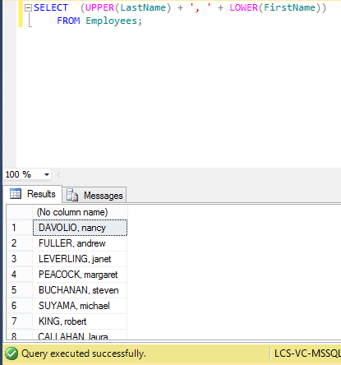

2.

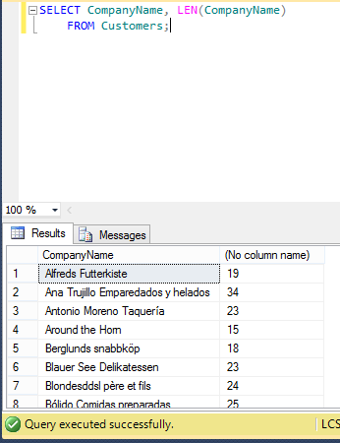

.

3.

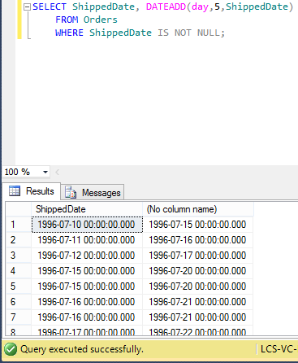

4.

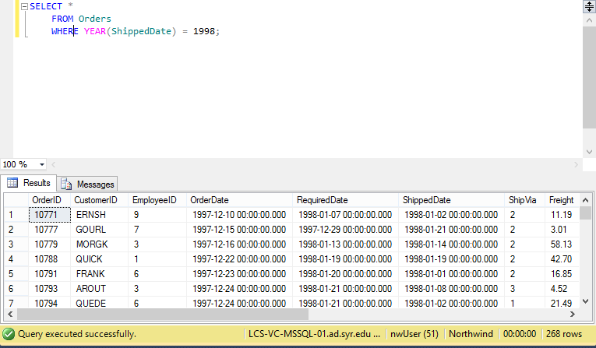

5.